Figure S1. Relative abundance of UNITE database fungal genus assignments of non-singleton (n > 1) culturable endophyte based on internal transcribed spacer (ITS) sequences from roots of seedlings grown in potting mix amended with steam-treated, plantation, and forest soil.

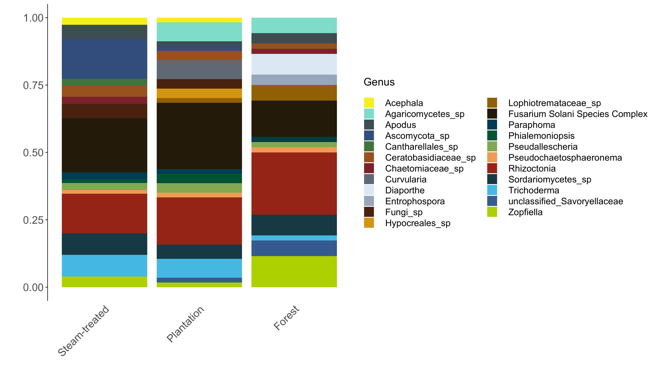

Figure S2. Majority-rules consensus RAxML tree (100 bootstraps, all nodes > 80%) of concatenated ITS and TEF-1a alignments (568 alignment patterns) from Fusarium cultures. Branch lengths proportional to substitutions per site; node values denote number of supporting bootstrap replicates. Red taxa are vouchers isolated in this study and include isolation source (Roots, Cankers, or Soil), treatment code (Non-sterile, Control, Trich, FSSC, and FSSC + Trich), and GenBank accession number in parentheses. \*Isolates with identical ITS+ TEF-1a sequences.



Figure S3. Isolation rates (Mean + adjusted SE number of colonies per plant) of fungi from cankers, roots (left axis), and soil (right axis) of walnut seedlings grown in untreated potting mix (NS) or in sterilized potting mix inoculated with filtrate only (C), Trichoderma asperellum Rh-366 (T), FSSC Rh-217 (F), or both Rh-217 and Rh-366 together (FT). Groups with different letters had significantly different reisolation rates within cankers, roots, and soil.

